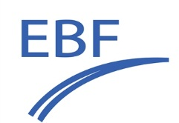 | IVDR – our Next Challenge?  6-7 June 2024  NH Málaga, Spain
Application for an Oral Presentation
Title of your presentation
Name of presenter:
Company/organisation:
E-mail of Presenter:
Highlight with “X” |  | I plan to present a case study of (potential) out of scope interpretation of the IVDR
 |  | I plan to present a case study of in-scope interpretation of the IVDR
 |  | My presentation will be on technology of CDx development
Biography
(max 150 words)
Abstract
(max 250 words):
Completed form should be send to focus@e-b-f.eu (in Word format, no PDF) prior to 15 March 2024.

Inclusion into the program will be evaluated by the organising committee and is based on its fit with the meeting goals. Abstracts with commercial, product placement or marketing intentions will not be accepted

We will communicate acceptance of your abstract before 24 March 2024

