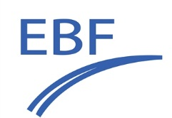 | Navigating Complexity in ADC Bioanalysis:  Scientific, Regulatory, and Practical Perspectives  June 18-19, 2026 - NH Málaga, Spain
Application for an Oral Presentation
Title of your presentation
Name of presenter:
Company/organisation:
E-mail of Presenter:
Highlight with “X” |  | - I plan to present in the session What to measure and why?
Highlight with “X” |  | - I plan to present in the session How to measure or not?
Highlight with “X” |  | - I plan to present in the session How to interprete?
Highlight with “X” |  | - I plan to present in the session And the regulations?
Biography
(max 150 words)
Abstract
(max 250 words):
Send completed form to focus@e-b-f.eu (in Word format, no PDF) prior to 21 March 2026.

Inclusion into the program will be evaluated by the organising committee and is based on its fit with the meeting goals. Abstracts with commercial, product placement or marketing intentions will not be accepted
All presentations will be given live at the meeting in Málaga. In view of the goals of the Focus Workshop, there will be no on-line opportunities provided.

We will communicate acceptance of your abstract before 10 April 2026

